|  |  |  |
| --- | --- | --- |
| Baghirov Maksud  Xb058t  Xb058t@inf.elte.hu Group number: 6 | First Assignment for OOP | 17th March 2024 |

# Task

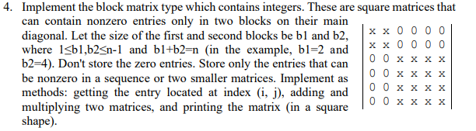

# Diagonal matrix type

***Set of values***

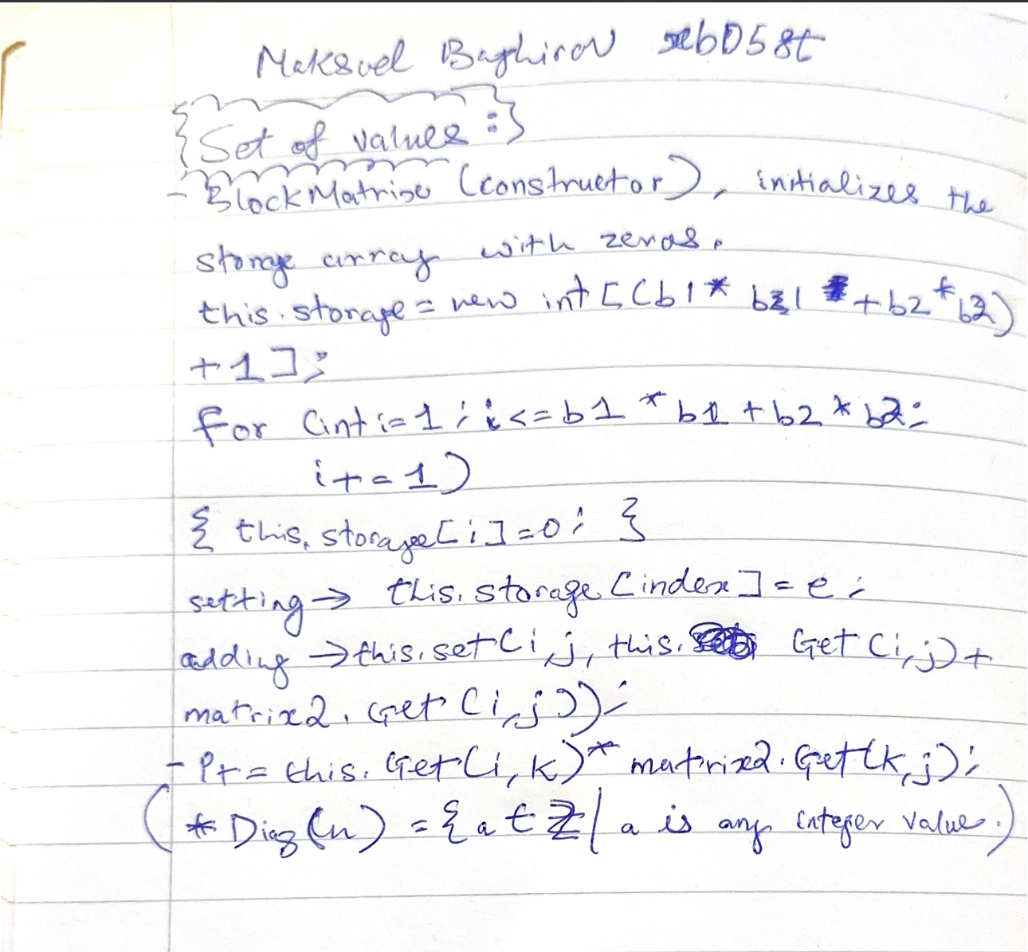

## Operations

1. *Getting an entry*

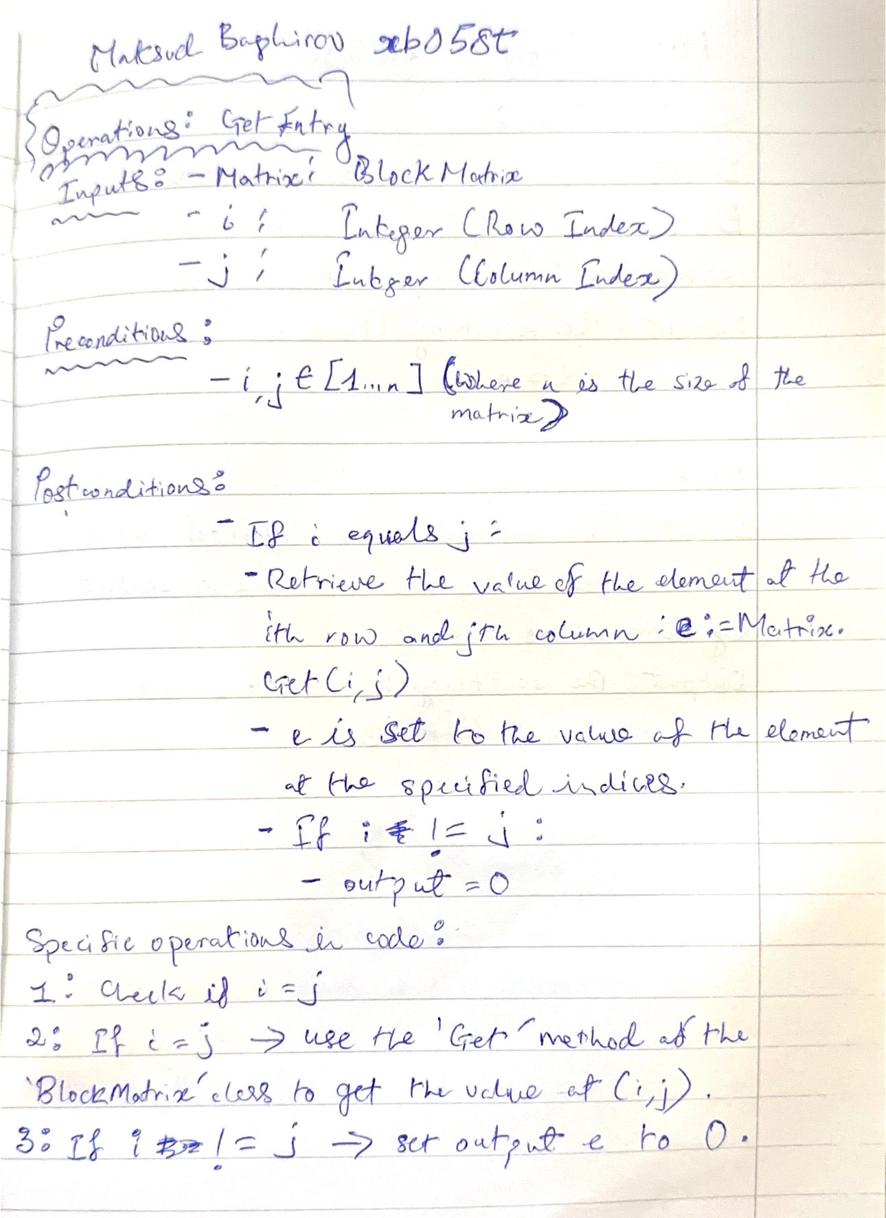

1. *Setting an entry*

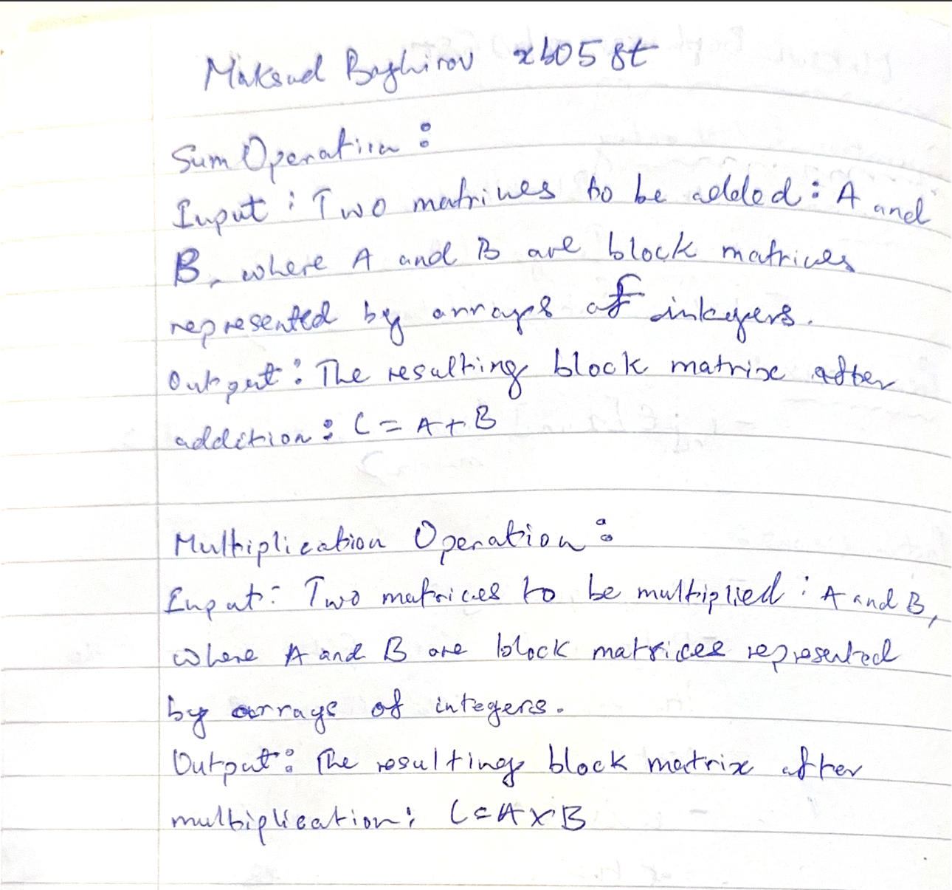

## Representation

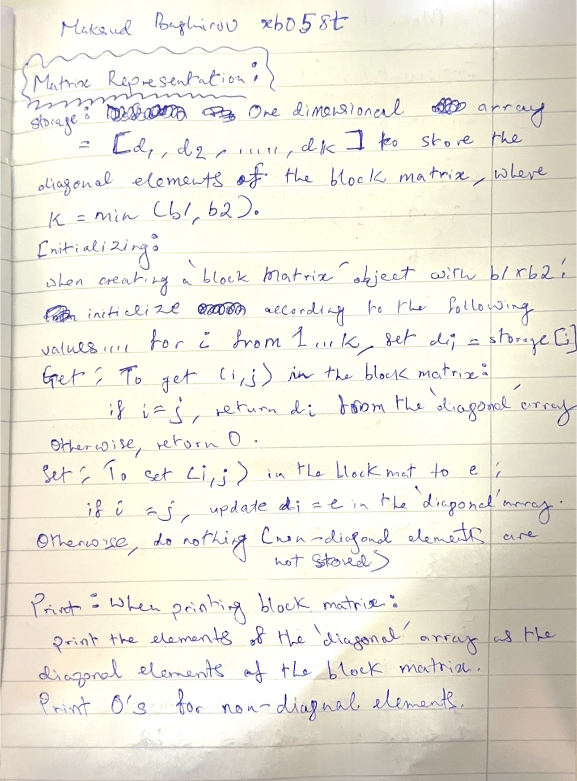

## Implementation[1]

1. *Getting an entry*

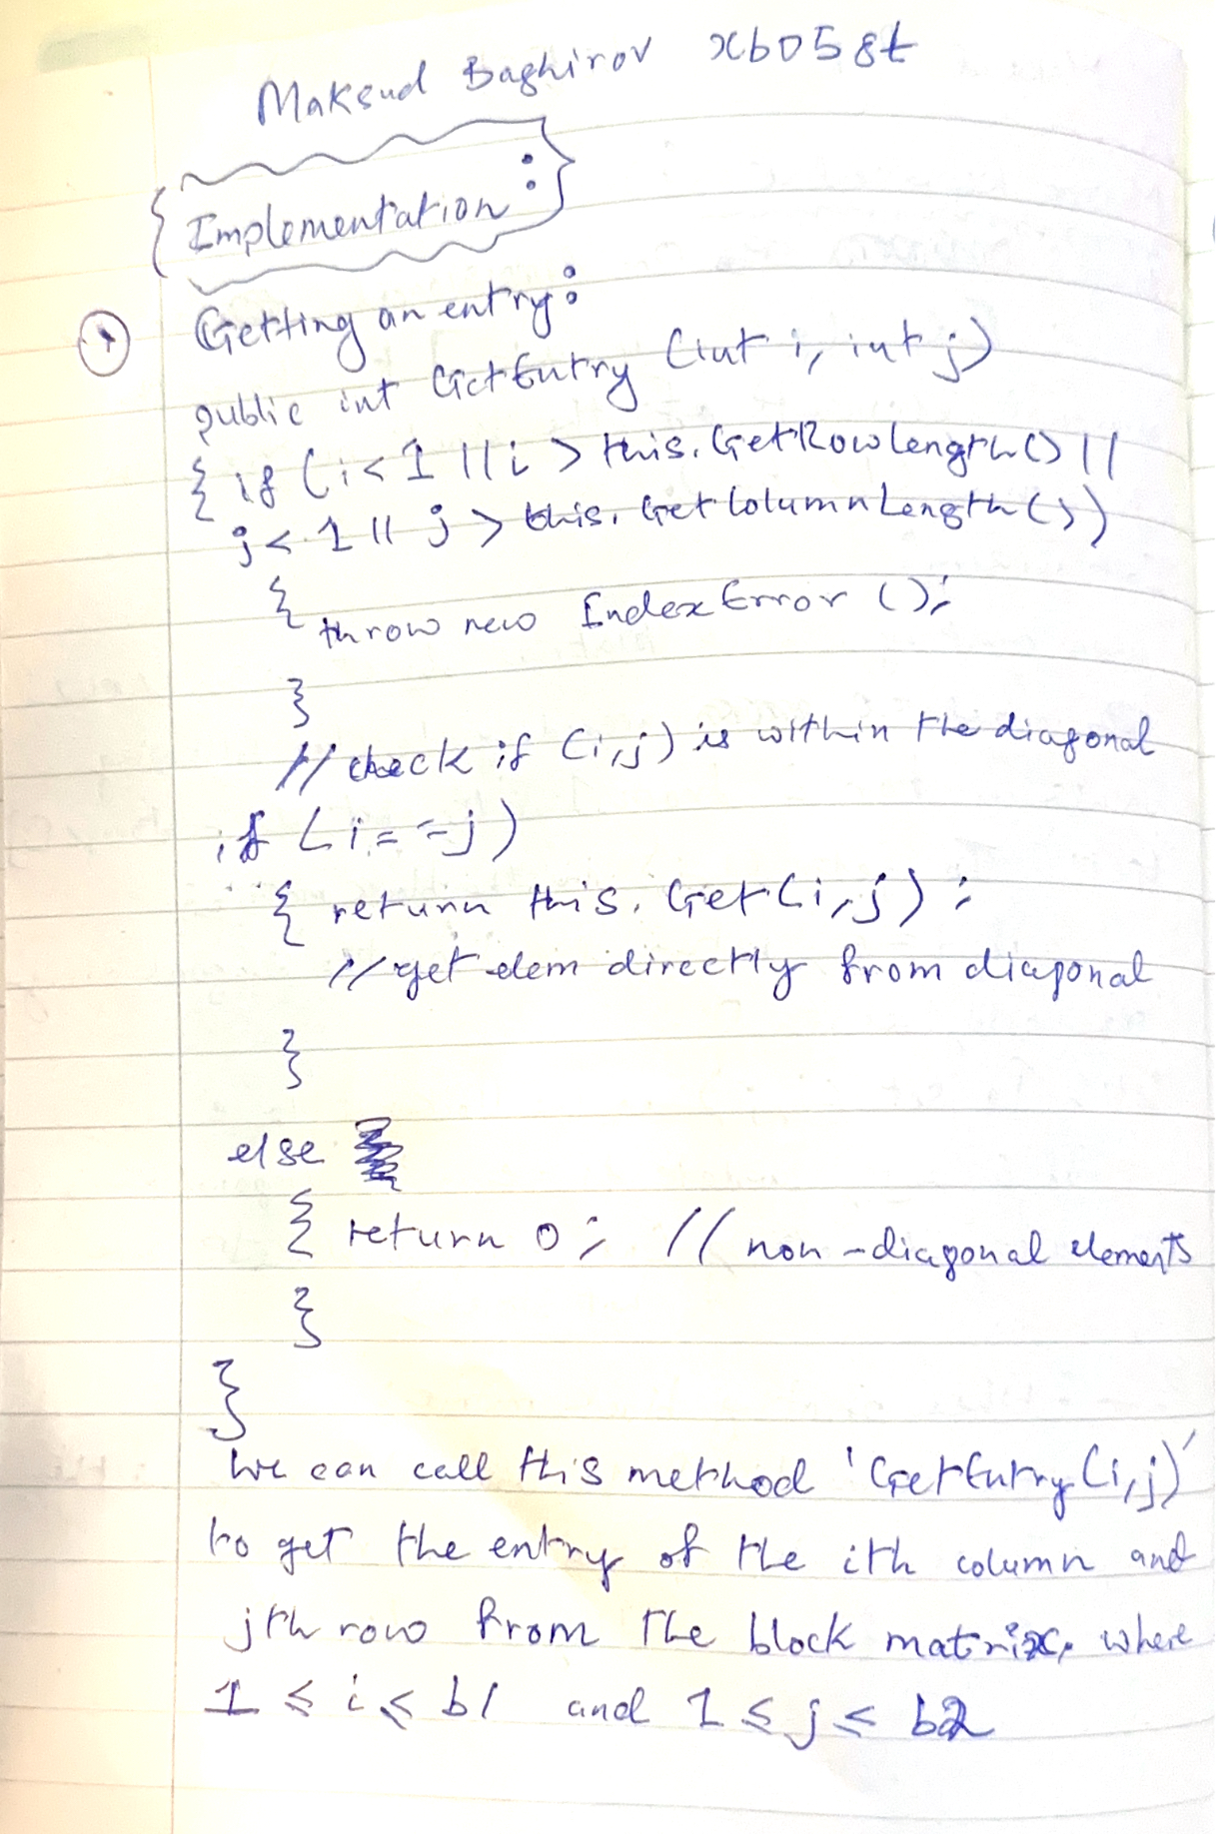

*i*

=

*j*

*e*

:=

*v*

[

*i*

*-*

*1*

]

*e*

:=

*0*

1. *Setting an entry*

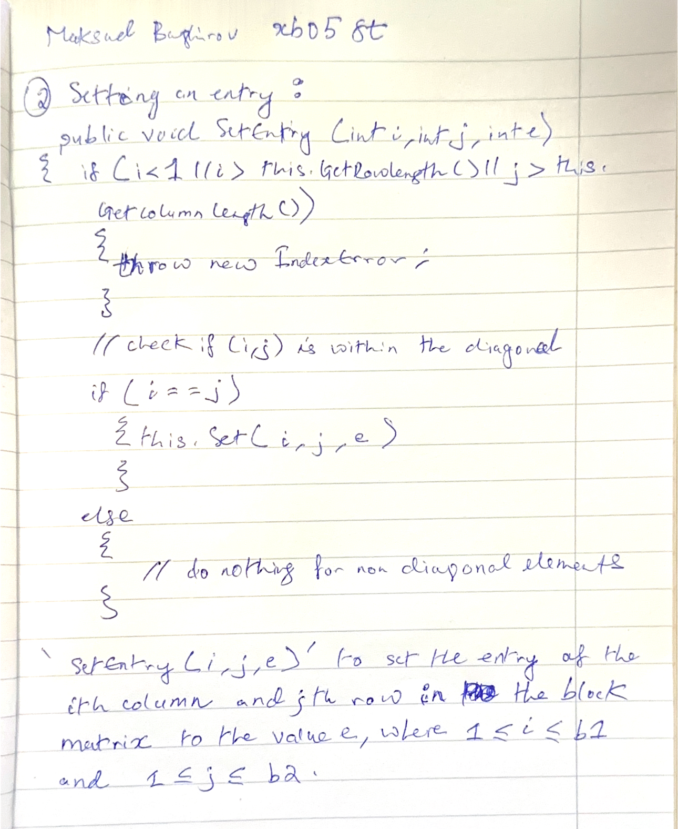

*i*

=

*j*

*v*

[

*i*

*-*

*1*

]:=

*e*

*SKIP*

# Testing

Testing the operations (black box testing)

1. Creating, reading, and writing matrices of different size.
   1. 0, 1, 2, 5-size matrix
2. Getting and setting an entry
   1. Getting and setting an entry in the diagonal
   2. Getting and setting an entry outside the diagonal
   3. Illegal index, indexing a 0-size matrix
3. Copy constructor
   1. Creating matrix *b* based on matrix *a*, comparing the entries of the two matrices. Then, changing one of the matrices and comparing the entries of the two matrices.
4. Assignment operator
   1. Executing command *b=a* for matrices *a* and *b* (with and without same size), comparing the entries of the two matrices. Then, changing one of the matrices and comparing the entries of the two matrices.
   2. Executing command *c=b=a* for matrices *a, b,* and *c* (with and without same size), comparing the entries of the three matrices. Then, changing one of the matrices and comparing the entries of the three matrices.
   3. Executing command *a=a* for matrix *a*.
5. Sum of two matrices, command *c*:=*a*+*b*.
   1. With matrices of different size (size of *a* and *b* differs, size of *c* and *a* differs)
   2. Checking the commutativity (a + b == b + a)
   3. Checking the associativity (a + b + c == (a + b) + c == a + (b + c))
   4. Checking the neutral element (a + 0 == a, where 0 is the null matrix) 6) Multiplication of two matrices, command *c*:=*a*\**b*.
   5. With matrices of different size (size of *a* and *b* differs, size of *c* and *a* differs)
   6. Checking the commutativity (a * b == b * a)
   7. Checking the associativity (a * b * c == (a * b) * c == a * (b * c))
   8. Checking the neutral element (a * 0 == 0, where 0 is the null matrix)
   9. Checking the identity element (a * 1 == a, where 1 is the identity matrix)

Testing based on the code (white box testing) 1.

Creating an extreme-size matrix (-1, 0, 1, 1000).

1. Generating and catching exceptions.

I made sure exceptions are handled well, generated and caught during matrix operations.

1. To implement an operation, a program has to be given (not necessarily structogram).